Project Design Phase-II
Data Flow Diagram & User Stories

Date | 25 September 2026
Team ID | 6ab4dd426603573ccfb5912f
Project Name | AI Blog Nest API
Maximum Marks | 4 Marks

Data Flow Diagrams:
A Data Flow Diagram (DFD) is a traditional visual representation of the information flows within a system. A neat and clear DFD can depict the right amount of the system requirement graphically. It shows how data enters and leaves the system, what changes the information, and where data is stored.
Level-1 Data Flow Diagram – AI BlogNest API:
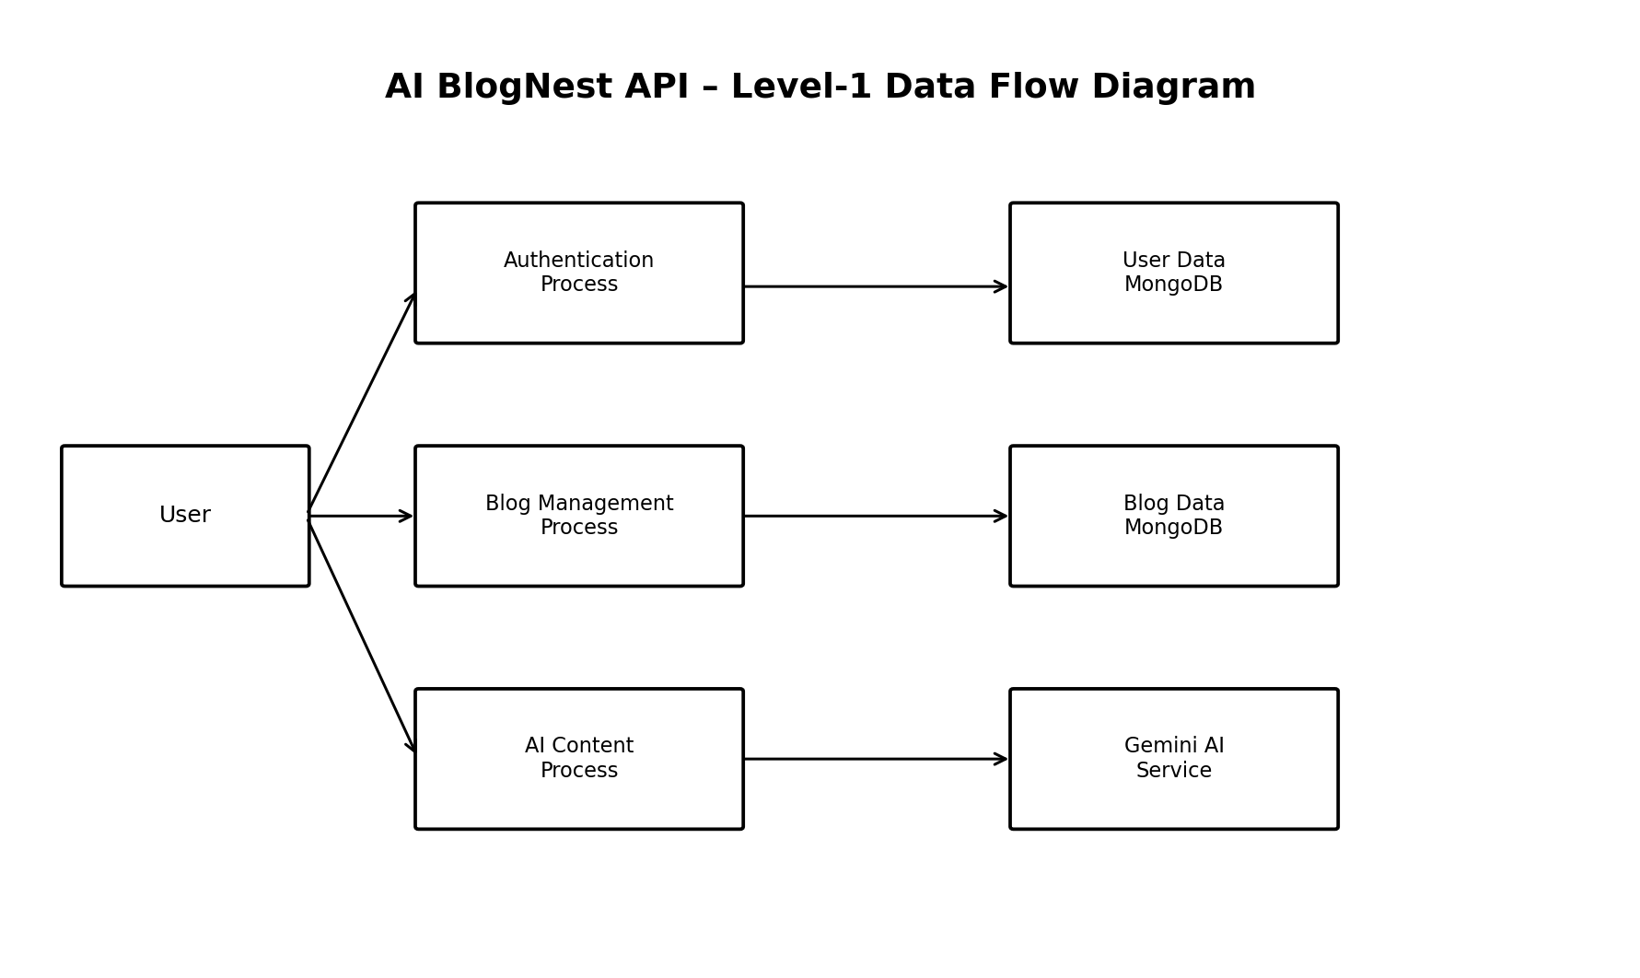
The DFD shows the primary information movement. A user or API client sends authentication, blog-management or AI-processing requests. The authentication and blog processes interact with MongoDB. The AI process sends prompts/content to Gemini and returns generated or summarized text.
Flow | Input | Processing | Output / Store
Authentication | Name/email/password | Validate, hash or compare password, issue/verify JWT | User record / JWT
Profile | Bearer JWT | Authenticate and load user | User profile JSON
Blog Creation | Title/content/category + JWT | Validate, authorize and create document | Blog document in MongoDB
Blog Retrieval | Blog ID or no ID | Query MongoDB and populate author | Blog JSON
Blog Update | Blog ID + changed fields + JWT | Check ownership and update | Updated blog JSON
Blog Deletion | Blog ID + JWT | Check ownership and remove | Deletion confirmation
AI Generation | Topic + optional category + JWT | Create prompt, call Gemini, clean output, infer category, store blog | AI-generated Blog document
Summarization | Content | Create summary prompt and call Gemini | Summary JSON

User Stories
Use the below template to list all the user stories for the product.
User Type | Functional Requirement (Epic) | User Story Number | User Story / Task | Acceptance criteria | Priority | Release
Registered User | Authentication | USN-1 | As a new user, I can register with name, email and password. | Successful user creation; duplicate email rejected. | High | Sprint-1
Registered User | Authentication | USN-2 | As a user, I can log in with valid email and password. | JWT token is returned for valid credentials. | High | Sprint-1
Registered User | Profile | USN-3 | As an authenticated user, I can view my profile. | Profile returns id, name and email without password. | Medium | Sprint-1
Registered User | Blog | USN-4 | As an authenticated user, I can create a blog. | Valid title, content and category are stored. | High | Sprint-2
Public User / API Client | Blog | USN-5 | As a user, I can view all blogs. | API returns blogs sorted by newest creation time. | High | Sprint-2
Public User / API Client | Blog | USN-6 | As a user, I can view one blog by ID. | Valid ID returns the blog; missing record returns 404. | Medium | Sprint-2
Registered User | Blog | USN-7 | As an author, I can update my own blog. | Only the owner can update it. | High | Sprint-2
Registered User | Blog | USN-8 | As an author, I can delete my own blog. | Only the owner can delete it. | High | Sprint-2
Registered User | AI | USN-9 | As an authenticated user, I can generate a blog from a topic. | Gemini generates 100–150 words and the blog is saved. | High | Sprint-3
Public User / API Client | AI | USN-10 | As a user, I can summarize blog content. | A concise summary is returned. | High | Sprint-3
Registered User | AI | USN-11 | As a user, I can omit a category during generation. | The API attempts category inference from topic keywords. | Medium | Sprint-3

